Day81 - Task39 - Kubernetes(Part-03)

1. Create a ClusterIP service for an Apache web server pod.
Step 1. Create an Apache Pod
- Create a YAML file: vi apache-pod.yaml and add the script.
- Save and exit.
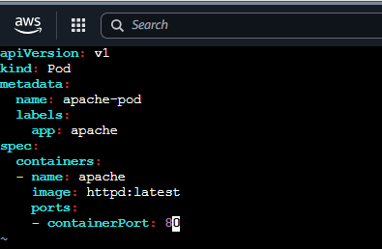
Step 2. Create the Pod
- kubectl apply -f apache-pod.yaml
- You should see: pod/apache-pod created
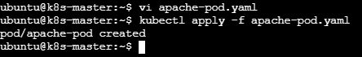
Step 3. Verify the Pod
- kubectl get pods
- You should see something similar to:
NAME | READY | STATUS | RESTARTS | AGE
apache-pod | 1/1 | Running | 0 | 10s
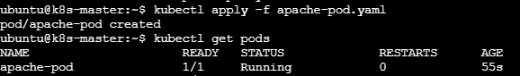
- Also verify the label: kubectl get pod apache-pod --show-labels
- You should see: app=apache
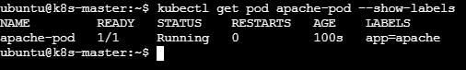
Step 4. Create the ClusterIP Service
- Create another YAML file: vi apache-service.yaml and add the script
- Save and exit.
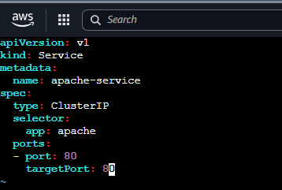
Step 5. Create the Service
- kubectl apply -f apache-service.yaml
- Expected: service/apache-service created
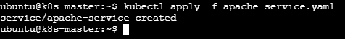
Step 6. Verify the Service
- kubectl get svc
- You should see something like:
NAME | TYPE | CLUSTER-IP | EXTERNAL-IP | PORT(S)
apache-pod | ClusterIP | 10.96.xxx.xxx | <none> | 80/TCP
- The important part is: TYPE = ClusterIP
- and: PORT = 80

Step 7. Check the Service Endpoints
- This is an important verification step: kubectl get endpoints apache-service
- You should get something similar to:
NAME | ENDPOINTS
apache-service | 10.244.x.x:80

- This confirms that the Service has found the Apache Pod.
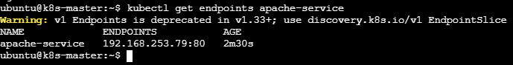
Step 8. Test the Apache Service from inside the cluster
- Because ClusterIP is accessible only inside the Kubernetes cluster, create a temporary testing pod: kubectl run test-pod --image=curlimages/curl -it --rm -- sh
- Inside the test pod, run: curl http://apache-service
- You should receive Apache's HTML response, something similar to: <html><body><h1>It works!</h1></body></html>
- You can also test using the full Kubernetes DNS name: curl http://apache-service.default.svc.cluster.local
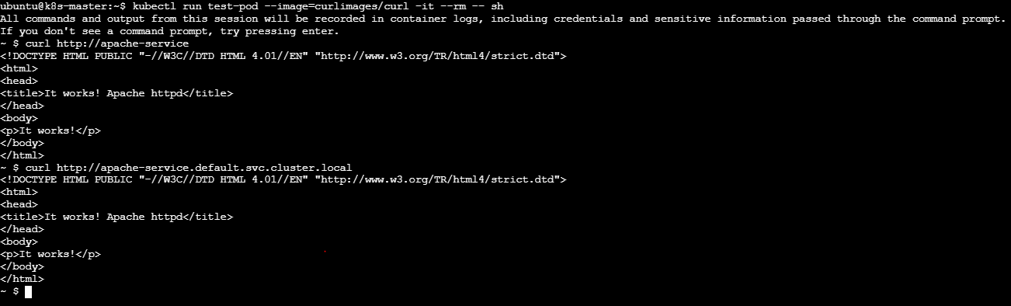
2. Expose an Nginx pod externally using a NodePort service.
Step 1. Create the Nginx Pod
- Run on your k8s-master:
- kubectl run nginx --image=nginx
- Check it: kubectl get pod nginx -o wide
- Wait until you see:
nginx | 1/1 | Running
Step 2. Create a NodePort Service
- Run: kubectl expose pod nginx --name=nginx-nodeport --port=80 --target-port=80 --type=NodePort
- What this does
  - nginx → exposes the Nginx Pod
  - --port=80 → Service port
  - --target-port=80 → Nginx container port
  - --type=NodePort → makes the Service accessible through a port on each Kubernetes node
Step 3. Check the Service
- kubectl get svc nginx-nodeport
- You should see something like:
NAME | TYPE | CLUSTER-IP | EXTERNAL-IP | PORT(S)
nginx-nodeport | NodePort | 10.96.x.x | <none> | 80:30xxx/TCP
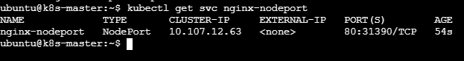
- 80:31390/TCP
- Here:
  - 80 = Service port
  - 31390 = NodePort
- The NodePort is normally in the range 30000–32767.
Step 4. Get the Node IPs
- Run: kubectl get nodes -o wide
- Your nodes are currently:
k8s-master 172.31.74.66
ip-172-31-71-65 172.31.71.65
ip-172-31-79-160 172.31.79.160
- For external access from your laptop/browser, you need the public IP of one of these EC2 instances.
- In AWS EC2, check the Public IPv4 address of the node.
5. Test the NodePort
- Service shows: 80:31390/TCP
- Then the URL is: http://<NODE-PUBLIC-IP>:30080
- For example: http://13.234.XX.XX:30080
- You should see the Welcome to nginx! page.
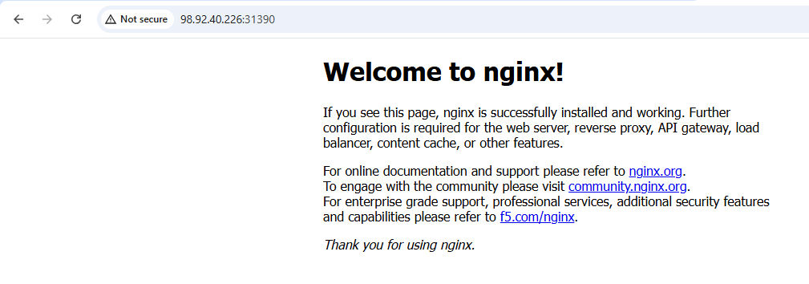
3. Deploy a Replication Controller to maintain 3 replicas of an Nginx pod.
Step 1. Create the ReplicationController YAML
- On k8s-master, create a file: vi nginx-rc.yaml and add
- Save and exit.
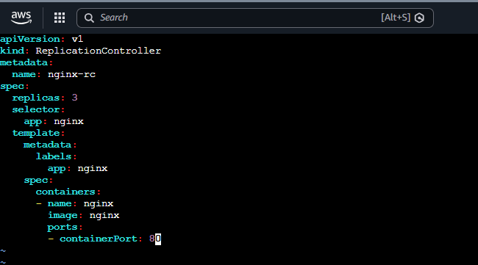
Step 2. Create the ReplicationController
- kubectl apply -f nginx-rc.yaml
- You should see: replicationcontroller/nginx-rc created
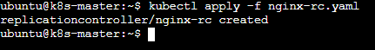
3. Check the ReplicationController
- kubectl get replicationcontroller
- or: kubectl get rc
- Expected:
NAME | DESIRED | CURRENT | READY | AGE
nginx-rc | 3 | 3 | 3 | …
- This means Kubernetes is maintaining 3 replicas.
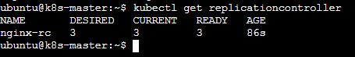
4. Check the Pods
- kubectl get pods -o wide
- You should see three Nginx Pods, for example:
  - nginx-rc-xxxxx 1/1 Running
  - nginx-rc-yyyyy 1/1 Running
  - nginx-rc-zzzzz 1/1 Running
- The exact Pod names will be different in your cluster
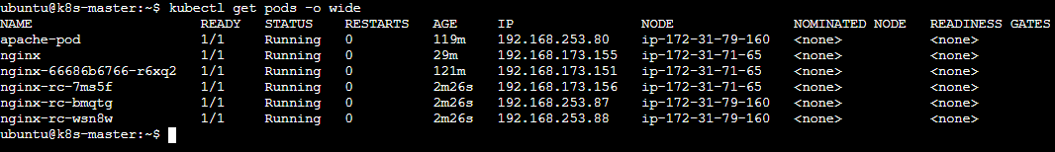
5. Verify self-healing
- This is an important part of a ReplicationController.
- First check: kubectl get pods
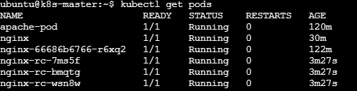
- Pick one of the Nginx Pods and delete it: kubectl delete pod nginx-rc-wsn8w
- Immediately check: kubectl get pods
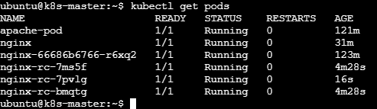
- Kubernetes creates a new Nginx Pod nginx-rc-bmqtg automatically.
- Check kubectl get pods –w
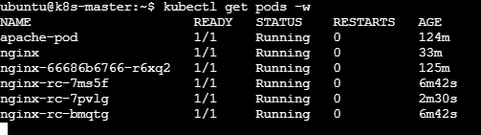
- The number of Pods should remain at 3.
- So the main requirement is:
- The Replication Controller continuously maintains 3 running Nginx Pod replicas.
4. Scale the ReplicationController from 3 replicas to 5 replicas.
Step 1. Scale the ReplicationController
- Run: kubectl scale rc nginx-rc --replicas=5
- Expected output: replicationcontroller/nginx-rc scaled
Step 2. Verify the ReplicationController
- kubectl get rc nginx-rc
- You should see:
NAME | DESIRED | CURRENT | READY
nginx-rc | 5 | 5 | 5
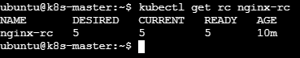
Step 3. Verify the Pods
- kubectl get pods -l app=nginx
- You should now have 5 Nginx Pods:
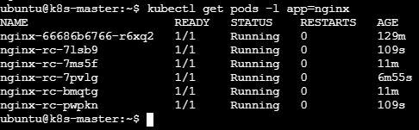
Step 4. Watch the scaling happen
- kubectl get pods -l app=nginx -w
- Kubernetes will create 2 additional Pods, changing: 3 replicas → 5 replicas
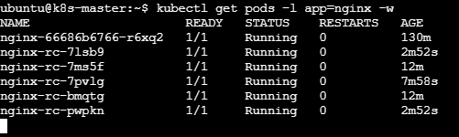
5. Create a ReplicaSet to manage pods based on multiple labels (prod and test).
Step 1. Create the ReplicaSet YAML
- Run: vi nginx-rs.yaml and add
- Save and exit.
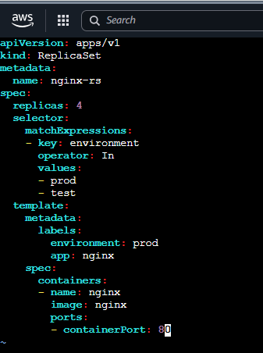
Step 2. Create the ReplicaSet
- kubectl apply -f nginx-rs.yaml
- Expected: replicaset.apps/nginx-rs created
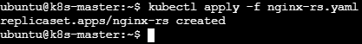
Step 3. Verify the ReplicaSet
- kubectl get rs
- You should see:
NAME | DESIRED | CURRENT | READY
nginx-rs | 4 | 4 | 4
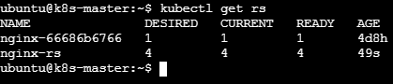
Step 4. Check the Pods and labels
- kubectl get pods --show-labels
- You should see 4 Nginx Pods with: environment=prod, app=nginx
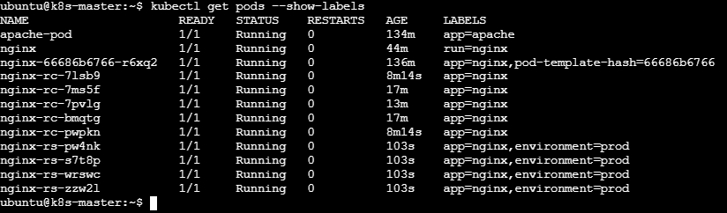
Step 5. Test the prod label
- kubectl get pods -l environment=prod
- This should show the Pods because prod is one of the values accepted by the ReplicaSet selector.
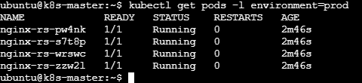
Step 6. Test the test label
- kubectl get pods -l environment=test
- Initially, this may show no Pods, because our Pod template creates Pods with: environment: prod
- The ReplicaSet selector:
  - operator: In
  - values:
    - - prod
    - - test
- means: "Manage Pods whose environment label is either prod OR test."
6. Deploy a ReplicaSet that excludes pods with the label backend.
Step 1. Create the ReplicaSet YAML
- vi nginx-rs-exclude-backend.yaml and add
- Save and exit.
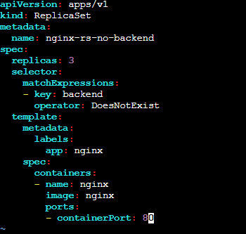
Step 2. Create the ReplicaSet
- kubectl apply -f nginx-rs-exclude-backend.yaml
- Expected: replicaset.apps/nginx-rs-no-backend created
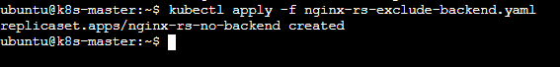
Step 3. Verify the ReplicaSet
- kubectl get rs
- You should see:
NAME | DESIRED | CURRENT | READY
nginx-rs-no-backend | 3 | 3 | 3
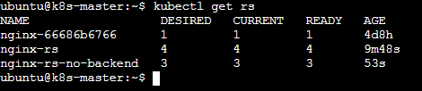

Step 4. Check the Pods
- kubectl get pods --show-labels
- The three new Pods should have: app=nginx
- and should not have: backend
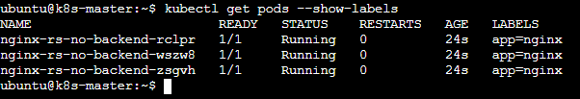
What ‘DoesNotExist’ means
- This part: matchExpressions: - key: backend
- operator: DoesNotExist
means:
- Select/manage Pods where the backend label does not exist.

Step 5.Verify the exclusion
- Create a test Pod with the backend label: kubectl run backend-test --image=nginx --labels="backend=true"
- Check: kubectl get pods --show-labels
- You should see a backend-test, but the ReplicaSet should not manage it.
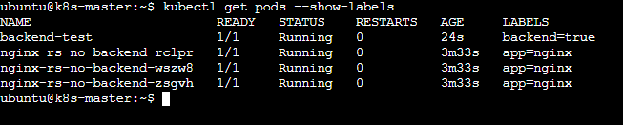
- Check the ReplicaSet: kubectl get rs nginx-rs-no-backend
- It should still maintain exactly 3 replicas.
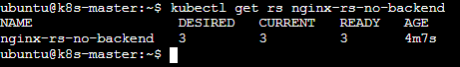
7. Test load balancing across multiple pods using a NodePort service.
Step 1: Check your existing Pods
- You already have 3 Pods from the ReplicaSet: kubectl get pods -o wide
- You should see:
  - nginx-rs-no-backend-xxxxx
  - nginx-rs-no-backend-yyyyy
  - nginx-rs-no-backend-zzzzz
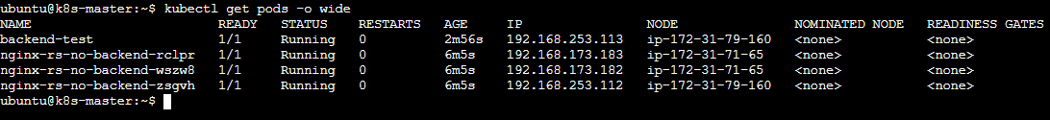
Step 2: Create a NodePort Service
- Create the YAML file: vi nginx-nodeport.yaml and add
- Save and exit.
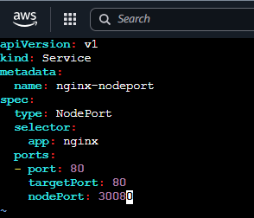
- Now apply it.
Step 3: Verify the Service
- kubectl get svc nginx-nodeport
- Expected:
NAME | TYPE | CLUSTER-IP | EXTERNAL-IP | PORT(S)
nginx-nodeport | NodePort | 10.96.x.x | <none> | 80:30080/TCP

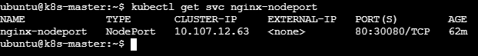
- Here:
  - 80 = Service port
  - 30080 = NodePort
  - targetPort 80 = Nginx container port
Step 4: Check which Pods are behind the Service
- Run: kubectl get endpoints nginx-nodeport
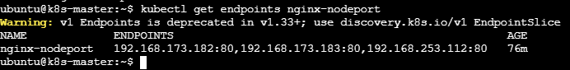
- You should see the IP addresses of your 3 Nginx Pods: nginx-nodeport 192.168.x.x:80,192.168.x.x:80,192.168.x.x:80
- This confirms that the Service is connected to multiple Pods.
- You can also verify with: kubectl get pods -l app=nginx -o wide
Step 5: Test the NodePort
- First get your worker node IPs: kubectl get nodes -o wide
NAME | INTERNAL-IP
k8s-master | 172.31.74.66
ip-172-31-71-65 | 172.31.71.65
ip-172-31-79-160 | 172.31.79.160
- From a machine that can reach the nodes, test: curl http://172.31.71.65:30080 (or) curl http://172.31.79.160:30080
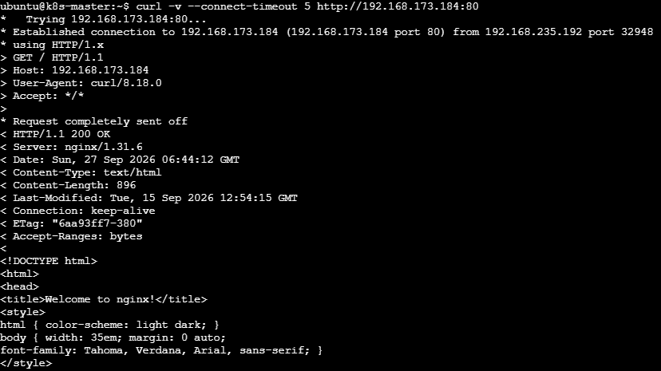
- You should receive the Nginx welcome page.
Step 6: Verify the load-balancing backends
- Run: kubectl get endpoints nginx-nodeport -o wide
- If you see all 3 Pod IPs, your NodePort Service is correctly connected to the 3 Nginx Pods.
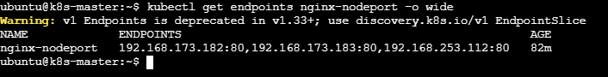
8. Delete a ReplicationController without affecting the running pods.
Step 1: Check your ReplicationControllers
- Run on k8s-master: kubectl get rc
- You may see something like:
NAME | DESIRED | CURRENT | READY
nginx-rc | 3 | 3 | 3
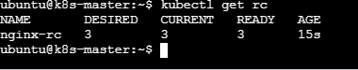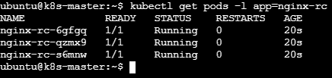
Step 2: Delete the ReplicationController but keep the above Pods
- kubectl delete rc ngi nx-rc --cascade=orphan
- Expected: replicationcontroller "nginx-rc" deleted
Step 3: Verify the RC is deleted
- kubectl get rc
- The RC should no longer appear.
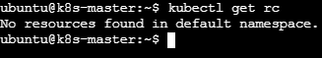
Step 4: Verify the Pods are still running
- kubectl get pods -o wide
